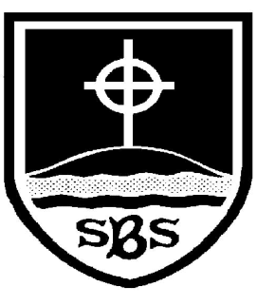 | St Bridget’s C of E Primary School  St Bridget’s Lane,  West Kirby,  Wirral CH48 3JT  Tel: 0151 625 7652  Headteacher: Mr Neil Le Feuvre  Email: schooloffice@stbridgets.wirral.sch.uk  Website: https://st-bridgets.eschools.co.uk/site  Together Everybody Achieves More  Faith, Hope and Love
Our Ref: Parl 1450
Multicultural Week 2016…Journeys

18th December 2015

Dear Parents & Carers
As you know, each year our school has a multicultural week where we focus on different cultures, nationalities and religions through a specific theme. This year our multicultural week we begin on Monday 11th January and will be focussing on the theme of Journeys. The children will be considering journeys they have made in their own lives and journeys they would like to take in the future, then we will be thinking about the experiences of refugees, including the experiences of Jesus as a refugee. Many of the year groups will be focussing on a particular group of refugees and also the contribution that refugees continue to make to society. If you feel that you have any expertise in this area, please contact your child’s class teacher, Mr Marriott or Miss Smith.

There have already been many different activities planned for this week and the children will explore this theme through all their lessons. Our art project for this week will be based on shoes. Please could you support us by sending in an old pair (we only need 1 but this will give us an error margin!) of shoes belonging to your child. The style of shoe is unimportant, ideally it needs to be a pair that would only be fit for the bin. Your child will then customise their shoe to reflect their own life journey, experiences, characteristics and past times. Also, children can bring in things that they want to attach or decorate their shoe to reflect their personality and journey.

If you have any further questions please contact Miss Smith via our school website using your child’s log on.
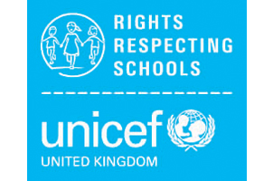
Wishing you all a peaceful Christmas.

Mr P Marriott Miss N Smith

