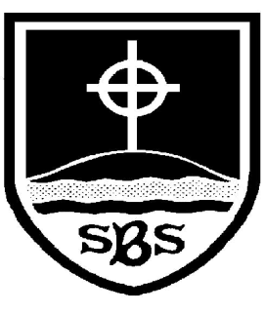 | St Bridget’s C of E Primary School  St Bridget’s Lane,  West Kirby,  Wirral CH48 3JT  Tel: 0151 625 7652  Headteacher: Mr Neil Le Feuvre  Email: schooloffice@stbridgets.wirral.sch.uk  Website: https://st-bridgets.eschools.co.uk/site  Together Everybody Achieves More
Thursday 11th September

Dear Parents,

Universal Free School Meals
This year the government has asked schools to provide all children from Reception to Year 2 with free meals for lunch. This is a big challenge for the school catering manager Mr Lloyd and his team, but I believe they are doing a great job and providing lots of good food. So far this term we have had a 90% take up and the children are enjoying their meals. If you would like your child to have a meal instead of a packed lunch please contact Mr Lloyd (0151 625 1904), especially if you have a concern or a special requirement.

Income Related Free School Meals
The new meal system has created some confusion for parents who may also be eligible for income related free school meals. If you qualify for income related free school meals extra funding is provided to the school for the educational provision for your child. Please use the link below to check whether you might qualify. Applications from anyone who qualified last academic year and haven’t had a change in their circumstances are not needed unless they want to add another child to the original application.
The website link for checking the eligibility criteria is www.wirral.gov.uk/free-school-meals

Earthfest
The Earthfest is this Saturday on the school field and is always well worth attending. The Earthfest helps to celebrate all the positive actions and activities that our local community enjoy. As always we pray for some good weather and plenty of visitors to support the event. Father Mike is still happy to speak to anyone who would like to offer some of their time on the day. He can be contacted by email - mgloach@gmail.com

Ice Bucket challenge!
Tomorrow thanks to a number of nominations and with the agreement of all the children in assembly I am undertaking the ice bucket challenge! All the children will watch this during the afternoon break time. In order to raise some extra money for charity I am asking for children to bring 50p or £1 on the day.

Art Success
Well done to Evie Clewes who was successful in winning an art competition held at Carr Farm during the summer holidays. The link is on our website.

Writing Success
Well done to the following children who have been successful in having their Super Hero stories published as part of a Young Writers Competition. The book is scheduled for publication on 31st October 2014.
- Harry McInerney - Mighty Morpher Vs Centre smasher
- Jamie Barnes - Captain Pea Disaster
- Ainara Schmid-Mielgo - Ironman and The Catgirl
- Anna Ledingham - Fury Rises…
Yours sincerely,

Neil Le Feuvre

