**We’ll be serving you an evening of entertainment:**

**Don’t Forget: 1st March**

**St Bridget’s PA Wine tasting & St David’s day fun**

**Book your place by Wednesday 27th February**



* **Quality wine tasting and Quiz with experts from Chester Beer &Wine.**
* **Small plates featuring Welsh delicacies**

**Following the wine tasting event … the World’s first Welsheoke; a celebration of Welsh bands and singers through the power of Karaoke. Loads of fantastic anthems to choose from (or to watch) and featuring a Special Guest perfomance.**

**TICKETS £10 per person: Deadline Wednesday 27th February- please complete form below and return with payment (cash or cheques payable to St Bridget’s Parents’ Association) to the PA box in an envelope marked PA ‘Wine tasting’.**

**If you are unable to attend on the night, you can still support the school and the event by donating a Wine, Cheese or Welsh related prize for our raffle that evening. We will collect any donations from the school gates on Thursday 28th/ Friday 1st March 8.45-9am and 3.15-3.40pm. Thank you in advance, all donations will be gratefully received.**

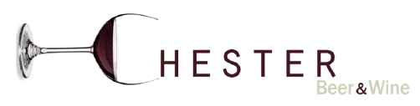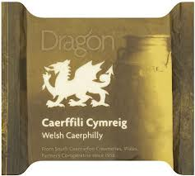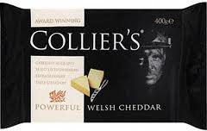

**---------------------------------------------------------------------------------------------------------------------**

**Name**

**E mail address**

**Child’s Class _______________**

**I enclose £____________ for _____places.**