St Bridget’s C of E Primary School

St Bridget’s Lane,
West Kirby,
Wirral CH48 3JT
Tel: 0151 625 7652
Headteacher: Mr Neil Le Feuvre
Email: schooloffice@stbridgets.wirral.sch.uk
Website: https://st-bridgets.eschools.co.uk/site

Together Everybody Achieves More

18th December 2015
Dear Parents,
The last day of term before Christmas is always exciting and the children started the day by proudly wearing their Christmas Jumpers and donating one pound for the Save the Children charity. Next stop we held our Christmas assembly. During this we thanked Mr Logan, a sport apprentice who is leaving and Miss Talib who has completed her final term of teaching with us. We wish them both every success in the future. We also thanked the members of the Parent Association who were able to share the news that the Christmas Fair raised over £5000. So thank you to everybody who supported this event. It was a fantastic day and a great success. The final part of the assembly involved the staff wishing the children a Merry Christmas. Last year we sang “Let It Go” but this year we did some acting (sort of) with our own version of the Bake Off. Anyway the main thing was the children thought it was great and laughed a lot. We have posted our efforts on the website for you to enjoy under the latest news.
Governor News
This is the first in what we hope will be a termly series on some of the activities of the school’s governors. The full governing body has met twice since September. The first meeting of the year is always dominated by the selection of the Chair (Nick Ledingham, for the second year), and the appointment of the committees in which much of the governors’ detailed work is done: the Curriculum Committee, the Finance, Buildings and Health and Safety Committee, and the Personnel and Staffing Committee. We also have an active Christian Ethos Committee. In addition, individual governors take on specialisms (literacy, numeracy, early years, SEN…) and visit the school, reporting back to governors on these topics.
Full meetings always receive a detailed report of the current issues in the school from Mr Le Feuvre. We have also been discussing the answers to 20 questions the Ofsted inspectors might ask, and developing a concise ‘vision’ for the school (of which more soon). The Curriculum Committee has been hearing about the wonders of Singapore Maths and the Personnel Committee has been considering the staff’s performance management and pay rises. A separate group of governors carries out Mr Le Feuvre’s performance management, with the help of an external consultant. One important concern that we discuss often is the ability of St Bridget’s to collaborate effectively with other schools, to counter the effects of gradually decreasing support from the local authority.
Andy Bates – Parent Governor
Wishing you a Merry Christmas,
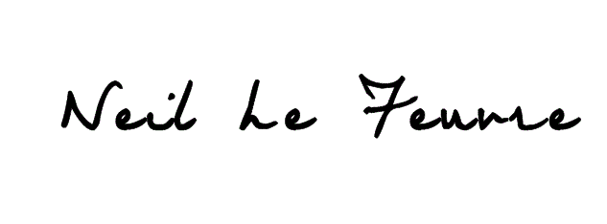
Neil Le Feuvre

