St Bridget’s C of E Primary School

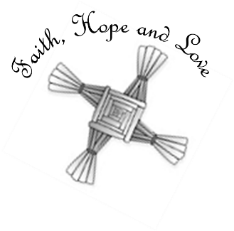
St Bridget’s Lane,
West Kirby,
Wirral CH48 3JT
Tel: 0151 625 7652
Headteacher: Mr Neil Le Feuvre
Email: schooloffice@stbridgets.wirral.sch.uk
Website: https://st-bridgets.eschools.co.uk/site

Together Everybody Achieves More

Our Ref: Parl 1463 29th April 2016
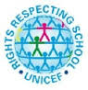

Dear Parents,
Your child has been given the template to make a rucksack. This is part of our RRSA campaign which aims to raise awareness that every child should go to school. The campaign itself is called ‘Send my Friend to School’; all around the world children miss out on school because of war, famine and natural disasters.
We aim to make lots of rucksacks with messages of hope, requesting help from world leaders. On Friday 13th May we will present our rucksacks to the local MP, Margaret Greenwood, who will take them to Parliament on Friday 24th June.
Please support your child to make the rucksack as part of their homework and return it to school next week. This campaign is an important part of your child’s learning and we hope our voices will be heard so that we can make a difference.
We have put additional information on our website (front page under Latest News).

Thank you for your support.
Neil Le Feuvre
Headteacher

