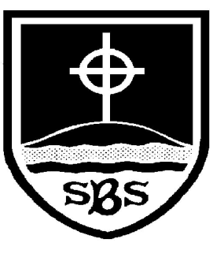 | St Bridget’s C of E Primary School  St Bridget’s Lane,  West Kirby,  Wirral CH48 3JT  Tel: 0151 625 7652  Headteacher: Mr Neil Le Feuvre  Email: schooloffice@stbridgets.wirral.sch.uk  Website: https://st-bridgets.eschools.co.uk/site  Together Everyone Achieves More  16th January 2014  Arts and Multi-cultural Week 2014
Dear Parents/Carers,
Next week will be our whole school Arts and Multi-cultural Week.
Our last one in 2012 celebrated the many cultures within our own country including Bengali, Indian, Irish, Polish and Chinese. A DVD was recorded of the children learning and creating through the week. This will soon be available to watch on our St. Bridget’s VLE in the Arts and Multi-cultural section.
This year we will be studying the Middle East – Syria in particular. As a Rights Respecting School, we have thought a lot about children around the globe. Our school as a whole, as well as individual children, have raised money for UNICEF and the Syria Appeal. We decided it would be beneficial to us all to have a deeper understanding of why there are problems in Syria and how UNICEF are trying to help children have their rights met. We have linked the week to the Article of the Month from the CRC – Article 14: freedom of thought, conscience and religion.
Although there have been difficulties in many of the Middle Eastern countries, they also have a rich culture steeped in wonderful art, music and dance. During the week the children will: look at and base own designs on a range of artwork from the region (thank you to Mrs Dunlop who will be helping the children create a whole school piece of art to be displayed in the school hall); listen to and perform popular music; learn about religions and beliefs; know that Jesus came from this area; learn about the geography of the area; and learn some belly dancing! (Thanks to Mrs Adams and Claire from Full of Beans) Mr. Lloyd the Catering Manager will also be creating some Middle Eastern food for the hot dinner menu on Tuesday 21st January.
On Friday 24th January it is non-uniform day. Children are to come to school wearing the colours of the Syrian flag (black, green, white and red), with a £1 donation for UNICEF’s Syria Appeal.
We are in the process of uploading the short film we made last year: Our Journey to Becoming a Rights Respecting School. It will be in the RRSA section of the VLE. Please take a look as the children did a fantastic job.
We thank you in advance for your on-going support.
Yours faithfully,

Mrs McCarthy (Arts and Multi-cultural Coordinator)

