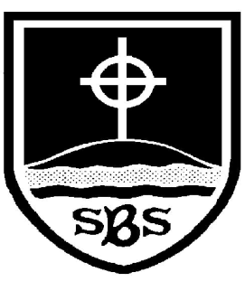 | St Bridget’s C of E Primary School  St Bridget’s Lane,  West Kirby,  Wirral CH48 3JT  Tel: 0151 625 7652  Headteacher: Mr Neil Le Feuvre  Email: schooloffice@stbridgets.wirral.sch.uk  Website: https://st-bridgets.eschools.co.uk/site  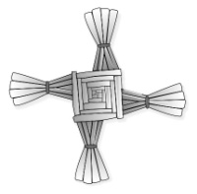  Together Everybody Achieves More  Faith, Hope and Love
Multicultural Week 2016…Journeys
8th January 2016

Dear Parents & Carers
As you know, each year our school has a multicultural week where we focus on different cultures, nationalities and religions through a specific theme. This year our multicultural week will begin on Monday 11th January and will be focussing on the theme of Journeys. The children will be considering journeys they have made in their own lives and journeys they would like to take in the future. We will also be thinking about the experiences of refugees, including the experiences of Jesus as a refugee. Many of the year groups will be focussing on a particular group of refugees and also the contribution that refugees continue to make to society.

As part of this celebration, Mrs Mountain, our school Catering Manager will be preparing a “Tasting Session” for Thursday afternoon. During this time the children will be able to try food from the Balkans, Iraq, Syria, Columbia and Africa.

All the food prepared will fit in with our normal allergy policy, however if your child cannot eat any of the foods below, please could you notify their class teacher.
- Houmous
- Falafel
- Pitta bread
- Basbousa cake
- Pancakes
- Sweet potato
- Tropical Fruits
- Cinnamon tea
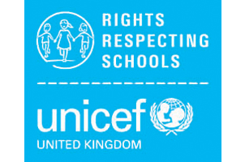
If you have any further questions please contact Miss Smith via our school website using your child’s log on.
Many thanks for your support.

Mr P Marriott Miss N Smith

