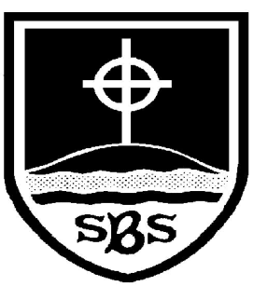 | St Bridget’s C of E Primary School  St Bridget’s Lane,  West Kirby,  Wirral CH48 3JT  Tel: 0151 625 7652  Headteacher: Mr Neil Le Feuvre  Email: schooloffice@stbridgets.wirral.sch.uk  Website: https://st-bridgets.eschools.co.uk/site  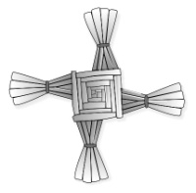  Together Everybody Achieves More  Faith, Hope and Love

10th December 2015

Dear Parents/Guardians,

Information for our Party Day!
(Thursday 17th December 2015)

Children can come to school in non-uniform (party clothes). As well as this, the children should bring in a small paper plate of party food, a carton drink and a party hat (optional). This should be brought in to school in a named bag, so as to avoid confusion. Please note that the party food is in addition to the children’s normal lunch!

PLEASE ENSURE THAT ALL FOOD IS NUT FREE

With thanks,

Year 6 Team

