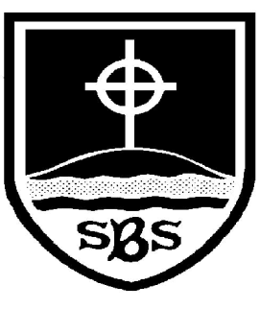 | St Bridget’s C of E Primary School  St Bridget’s Lane,  West Kirby,  Wirral CH48 3JT  Tel: 0151 625 7652  Headteacher: Mr Neil Le Feuvre  Email: schooloffice@stbridgets.wirral.sch.uk  Website: https://st-bridgets.eschools.co.uk/site  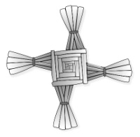  Together Everybody Achieves More  Faith, Hope and Love

Excite, Enhance, Celebrate!
Year 6
Dear Parents,

As we continue to find creative and innovative ways of enhancing our curriculum, we are delighted to say that this term your child will be working on the topic of ‘The Vikings,’ thinking in particular about whether the Vikings were always vicious and victorious! This will provide the basis for a cross-curricular approach to many of the subjects your child will learn this term.

We hope that you can support your child by researching any aspect of the Vikings, perhaps by collecting images and information. We would like each child to share their knowledge with the class throughout this project.

As part of our topic we will be visiting St Bridget’s Church to explore the Hogback stone as well as St Bridget’s museum to explore other Viking artefacts.

If you feel that you have something to contribute to this topic, perhaps you work in this field, then please feel free to contact us – we’d love you to come and share your expertise!

Yours faithfully

Mrs J Carver Mrs V Neal

