St Bridget’s C of E Primary School
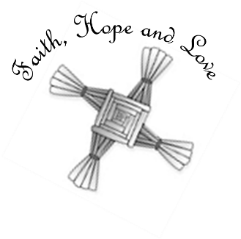
St Bridget’s Lane,
West Kirby,
Wirral CH48 3JT
Tel: 0151 625 7652
Headteacher: Mr Neil Le Feuvre
Email: schooloffice@stbridgets.wirral.sch.uk
Website: https://st-bridgets.eschools.co.uk/site

Together Everybody Achieves More

24-3-16

Dear Parents,

Happy Easter and thank you to all of the year 3 children who led our Easter Service and to all the parents who came and joined us for tea and coffee afterwards. Easter offers each of us a message of hope and helps us to continue to think about the positive changes we can make in our lives. The challenge throughout Lent was to reduce food waste in school and I am pleased to say that many of the children succeeded in doing this for themselves. The challenge now is to continue this at school and discuss how this can be promoted at home. The Rights Respecting Steering will continue discussions about this Campaign after Easter.

Parking in the local area
Last week I received an email from a local resident who is continually frustrated by some parents who park across his drive. While I accept the local roads are not suitable for lots of school traffic many of our parents manage to get their children to school in a way that is considerate to the local residents. In school we continually promote the values of courtesy and respect with the children and I would ask that we all do this as adults. Our children look to us as role models. Please take more time to park carefully and considerately.

Staff News
I am pleased to confirm that Mr Heathcote will be covering Mrs Carver’s maternity leave (from May 3rd) and Mrs Sadler-Jones will do the same in place of Miss Cotterell (from April 29th). Both teachers have started to visit their classes and are getting to know the children in order to enable a smooth transition.

Sport Relief
Thank you for the great support on our ‘Mad March Hair and Marathon Day’, we are delighted to say we raised £325 as a school on behalf of Sports Relief.

Sporting Success
We recently competed at the Merseyside Games Athletics competition achieving a highly creditable top 10 finish. The competition brings together the top school teams across the Merseyside region.

Well done to the three hockey teams that represented St. Bridget’s in a hockey tournament this week. After lots of fun the B-team won their group and nearly made it through to the final rounds of the competition.

Well done to Chelise in year 5 who recently won a silver medal at a national judo competition.

Well done to Charlie in year 6 who won the competition to name the new development in West Kirby. The winning name was Blue Stones.

Polite reminders

Scooters and Bikes
If you are arriving at school on a scooter or a bike please dismount before coming down the school drive or on the playground. We have had a number of collisions with pedestrians and near misses with cars in the car park.

Plasters
After a recent update for training for our First Aiders we will now be using hypo-allergenic plasters for any small injuries. Please contact the school office if you have any concerns about this.

Mobile phones in school
Sometimes children in year five and year six need to bring mobile phones into school because they travel home by themselves. In each of these cases parents have written a letter outlining the reasons and requesting permission for their child to be allowed to bring a mobile phone into school. If a child does bring a mobile phone into school they must hand it in to the class teacher until the end of the day.
Please ensure that your child does not bring in their phone if they do not have permission.

Uniform
Please could you ensure that your child is wearing the correct uniform. Increasingly we are seeing children wearing trainers and alternatives to the school jumpers. Whilst we understand that sometimes this is needed as a stop gap measure, several children have been wearing ‘alternatives’ for a few weeks.

New Contact information
Please let the school office know if you have any new contact information so that we are able to keep our records up to date.

Yours sincerely,
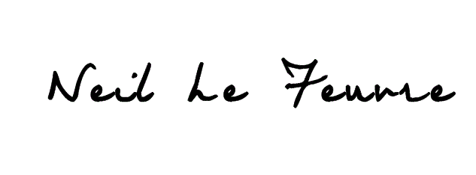
Neil Le Feuvre

