St Bridget’s C of E Primary School

St Bridget’s Lane,
West Kirby,
Wirral CH48 3JT
Tel: 0151 625 7652
Headteacher: Mr Neil Le Feuvre
Email: schooloffice@stbridgets.wirral.sch.uk
Website: https://st-bridgets.eschools.co.uk/site

Together Everybody Achieves More

Our ref: Parl 1466
17th June 2016

Robin Wood Residential 31st October – 2nd November 2016
Balance Due

Dear Parents / Guardians
The residential will take place at Robin Wood, Dobroyd Castle in Lancashire, from 31st October to Wednesday 2nd November. During this time your child will take part in many outdoor activities, which include: archery, canoeing, caving, crate challenge, giant swing, trapeze and zip wire to name but a few! All meals, drinks, snacks and transport are included in the cost.
The remaining balance, of £150, is due by Friday 1st July.

Yours sincerely
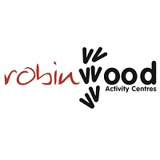
Year 5 and 6 Team

