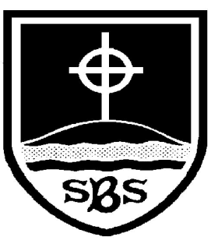 | St Bridget’s C of E Primary School  St Bridget’s Lane,  West Kirby,  Wirral CH48 3JT  Tel: 0151 625 7652  Headteacher: Mr Neil Le Feuvre  Email: schooloffice@stbridgets.wirral.sch.uk  Website: https://st-bridgets.eschools.co.uk/site  Together Everybody Achieves More

Friday 19th December

Dear Parents,

This last week has seen all of the school participate in wonderful Christmas Services. Thank you for all the great feedback we have received, I am glad you enjoyed them. The children have helped everyone who has seen the services to remember the important messages of Christmas and the birth of Jesus. In our Christmas Assembly today we thanked all of the children for all of their help in raising money for charity during Advent. We managed to raise money for UNICEF, Oxfam, The Royal British Legion and Save the Children. As well as this we raised over £400 for Children in Need in November.

During assembly we thanked representatives of the Parent’s Association for all their support in raising over £4000 at the Christmas Fair. This year the Parent’s Association has agreed to jointly fund the upgrade and purchase of new ICT equipment throughout the school. Without the continued support from the Parents Association some of our upgrades would take longer to purchase and so I thank all of you for your continued help in every event you attend and support. It does make a real difference to the children in our school.

Staffing News
At the end of this term we have said goodbye to Mrs Booth who has worked as a teaching assistant in our school for fourteen years. We have also said good bye to Mrs Cain one of our midday assistants who has worked at St. Bridget’s for seven years. Earlier in the term we also said goodbye to Mr Lloyd our Catering Manager. Mr Lloyd was instrumental in ensuring all of children are served healthy meals cooked fresh each day and we thank him for all of his service to the school. His position has been taken over by Mrs Mountain who was previously Mr Lloyd’s assistant. We wish all of the staff who are leaving every success for the New Year.

Thank You Father Mike
As you may know Father Mike leaves the parish of St. Bridget’s soon to take over his own parish in the Bebington area. Father Mike has been a tremendous influence both in school and the parish. This morning in a small service in church all of the staff thanked him for his time, commitment and enthusiasm. We wish him well in the New Year.

Merry Christmas
Each year at the end of the Christmas Assembly staff normally sing something fun for the children and wish them a Merry Christmas. This year the staff took some inspiration from the film Frozen the results of which are posted on the website under News! We hope you enjoy our recording as much as the children did and may I take this opportunity to wish you all a Merry Christmas.

Yours sincerely,

Neil Le Feuvre

